Data Science Team GitHub Tutorial
This tutorial is about Data Science Team how to use GitHub.
The GitHub desktop is used here as a demonstration. You can also use git. Git can select one branch, but the GitHub desktop does not support this. But GitHub desktop is simpler to use.

Branch
Chameleon GitHub：https://github.com/Chameleon-company
Then select MOP-Code.
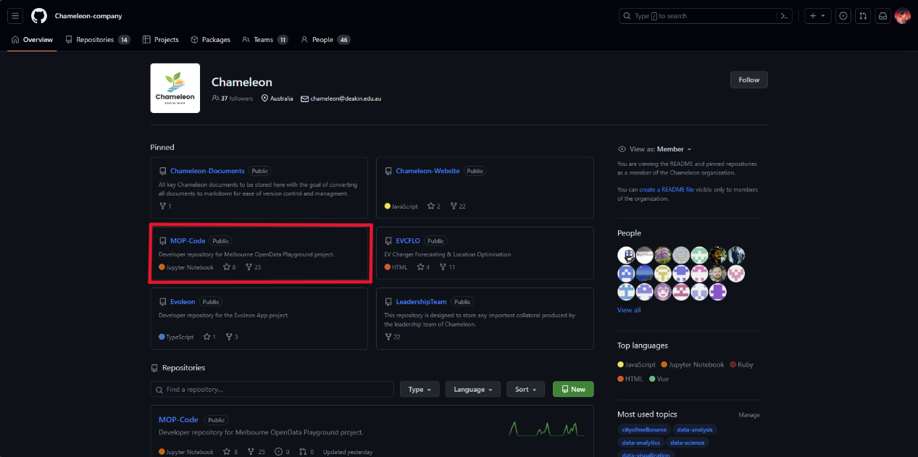

Then select branches.
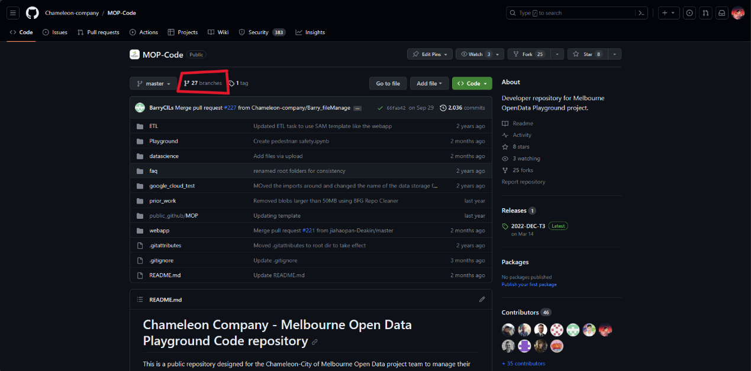

Click to create a new branch.
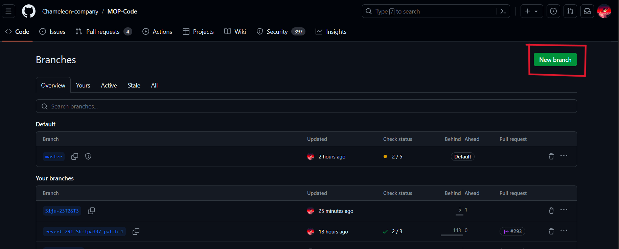

Make sure you copied from the master.
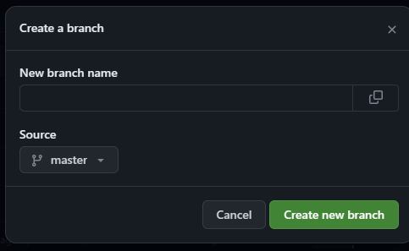

Return to the MOP-Code page and click Code. Choose to open in GitHub desktop.
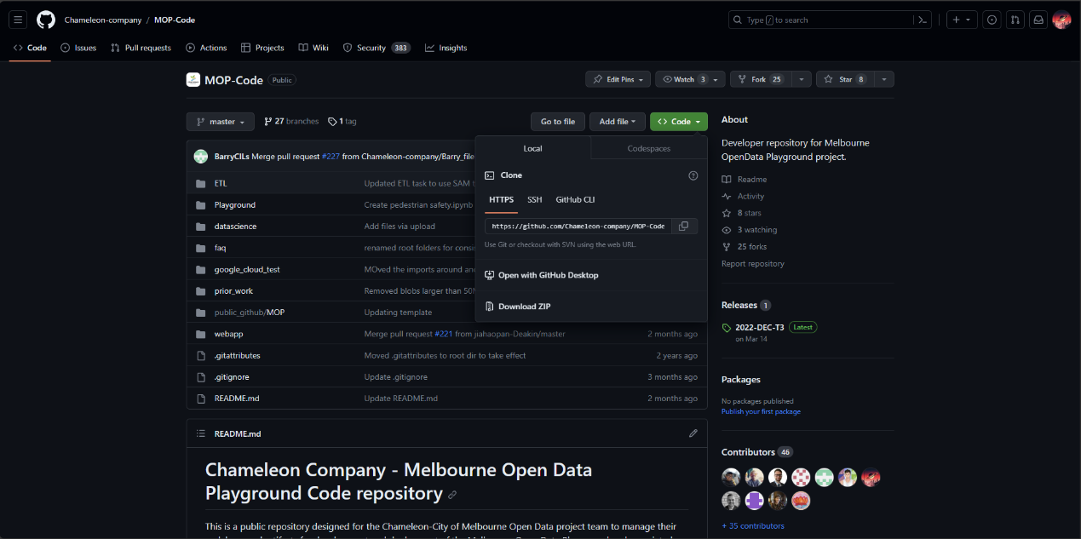

Select a local storage location. Note: The entire file is 5GB.
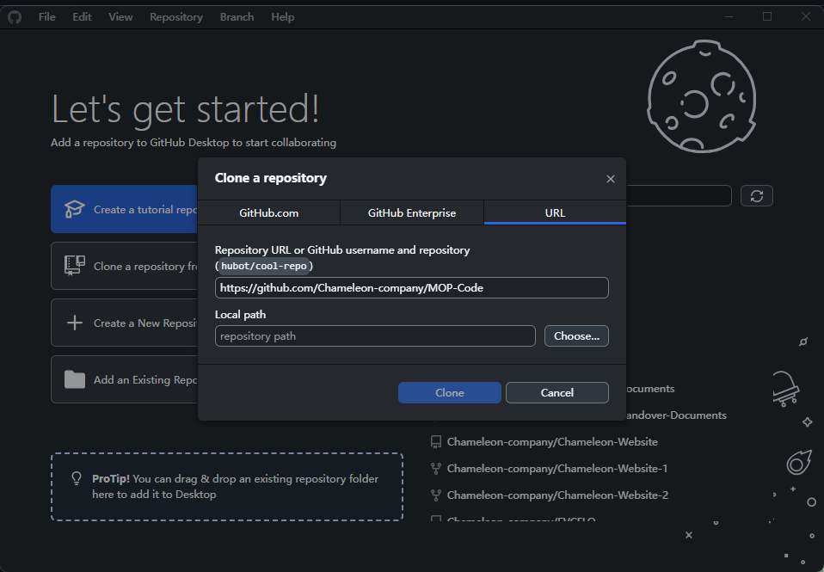

Local sync
Return to the MOP-Code page and click Code. Choose to open in GitHub desktop.


Select a local storage location. Note: The entire file is 5GB.


Then select your branch. You should not work directly on the master. Never
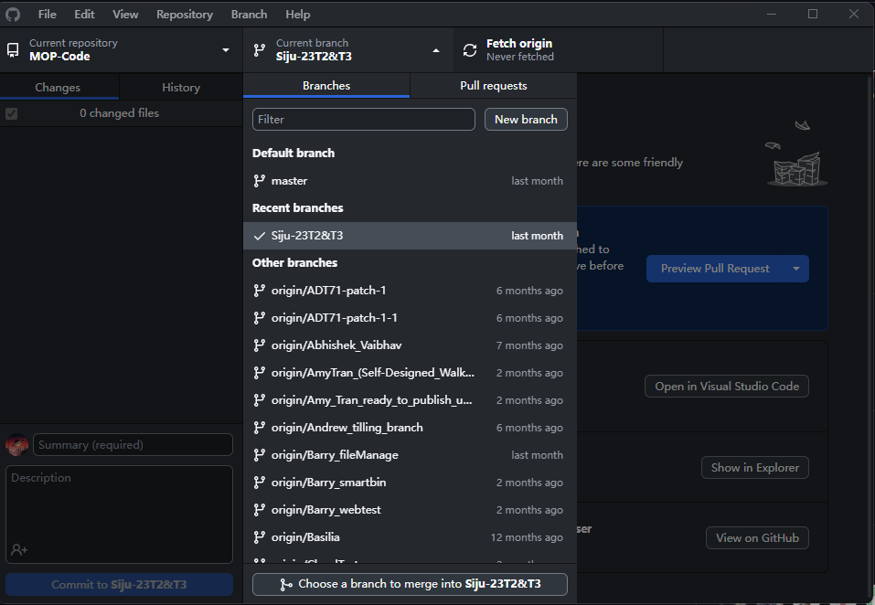

Start personal work.
Now, you can do it directly locally. Please create your name folder within the Playground folder.

You can then see your changes on the GitHub desktop. If you create an empty folder, the changes may not appear. You can do this after you start working on it.
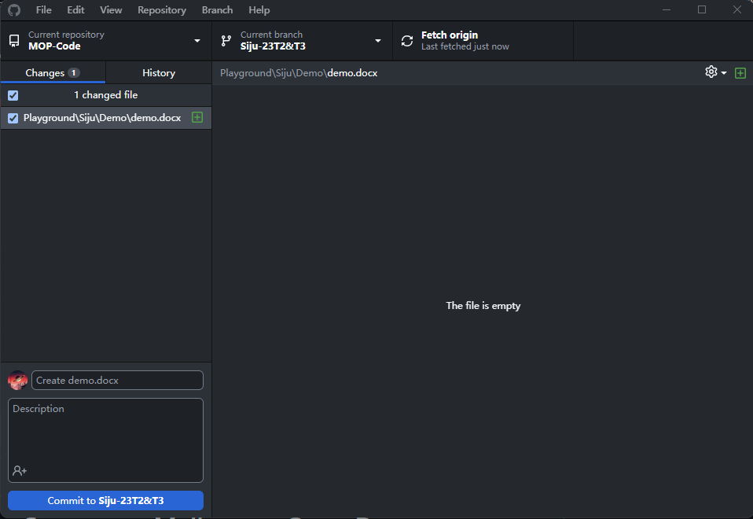

After saving the changes, sync to GitHub.
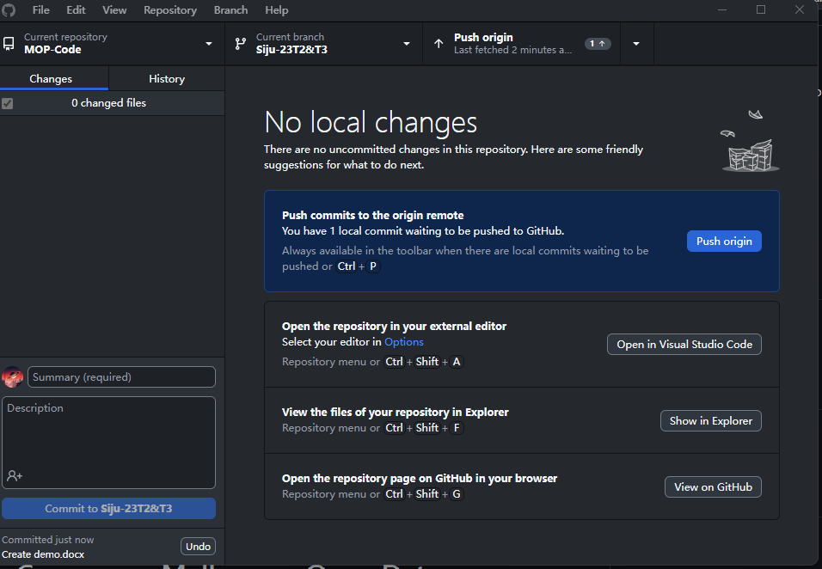

Pull request.
You can check the progress of your branch. If your work is stages completed, please create a pull. Most works are in personal folders until the notebook is ready to publish.
In the branch you can view the branch progress
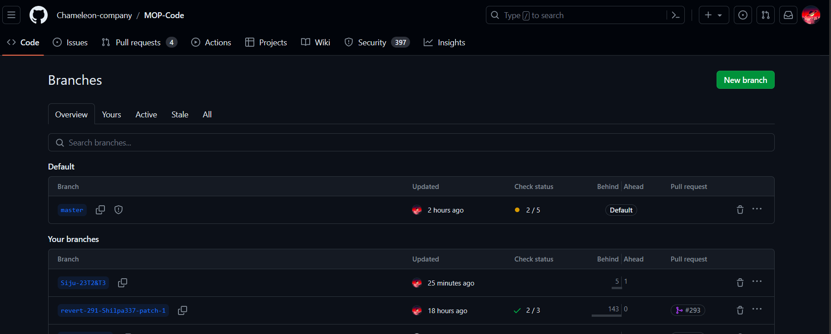

Use GitHub Desktop
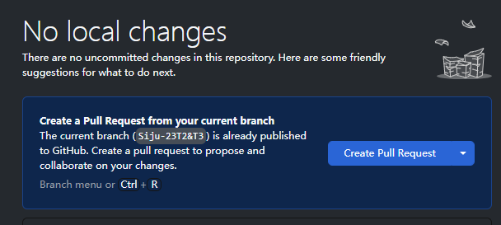

Use GitHub Website
You can see the prompt on the web page after uploading.
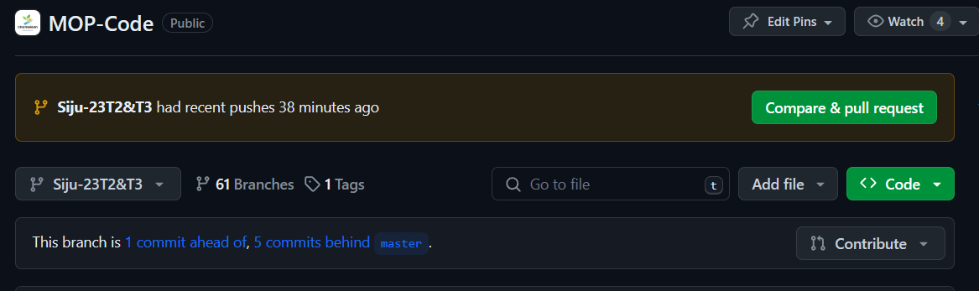
You can also choose your own branch and click “ahead to”


Then create pull request. Please make sure you are going from the personal branch to the master.
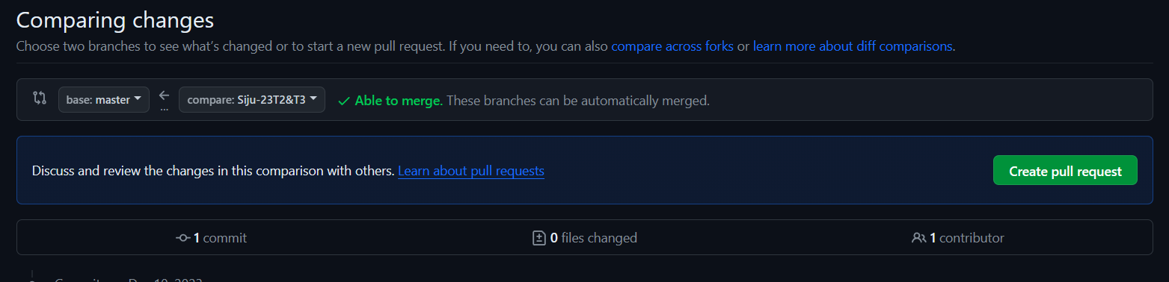

Create request.
Please describe what your pull is.
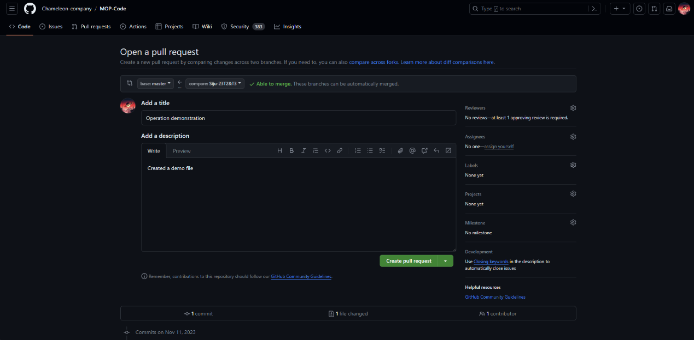

Our pulls require review. So please select one team leader for approval.
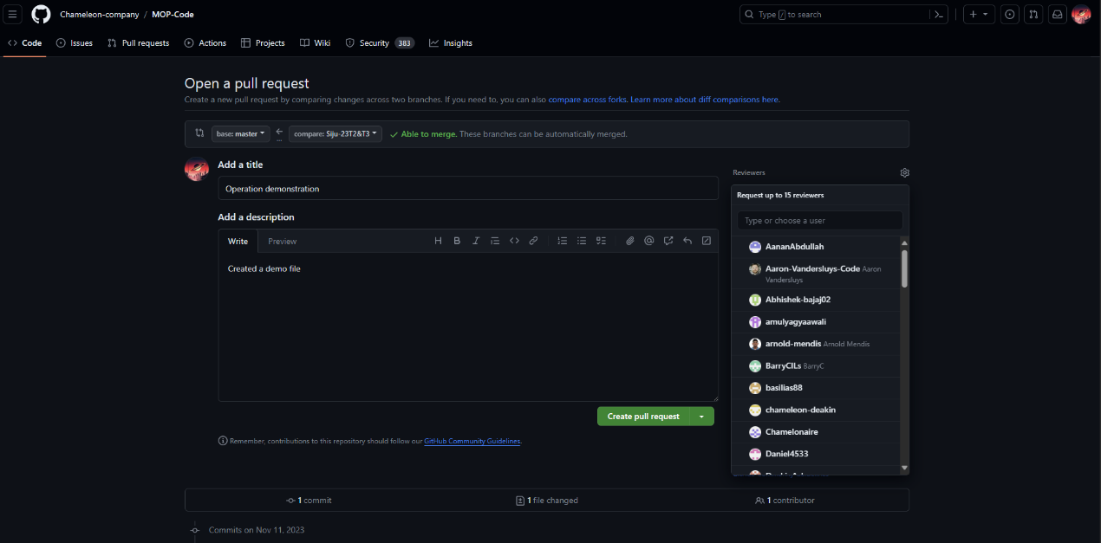

Update personal branch.
After others’ submissions, your branch will behind the master branch. Please update your branch.

Use GitHub website.
On the web page, it is also a pull, but the direction changes to import from the master. Click on the “behind”.


Then create pull request. Please make sure you are going from the master to the personal branch.
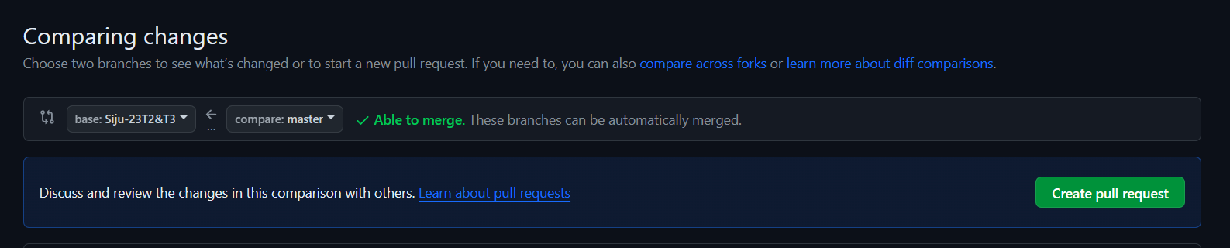

Use GitHub desktop.
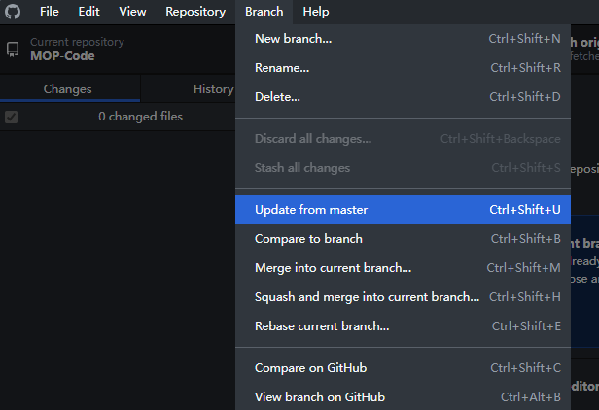

Author
Siju Deng

